[How to extract feature service data with attachments enabled from ArcGIS Online](http://communityhub.esriuk.com/technicalsupport/2014/4/14/how-to-extract-feature-service-data-with-attachments-enabled.html)

[April 14, 2014](http://communityhub.esriuk.com/technicalsupport/2014/4/14/how-to-extract-feature-service-data-with-attachments-enabled.html)

There may be a need to make a local copy of attachments stored in a hosted feature service within an ArcGIS Online organisation account, for instance for backup purposes. The instructions below will guide you through the steps of how to do this.

**Create a replica**

Log in to your AGOL account, go to '*My Content*' and browse to the attachment enabled Feature Service you need to extract from.

For small datasets:  
1. From the description page of the hosted feature service with attachments enabled, follow the '*Service URL*'.

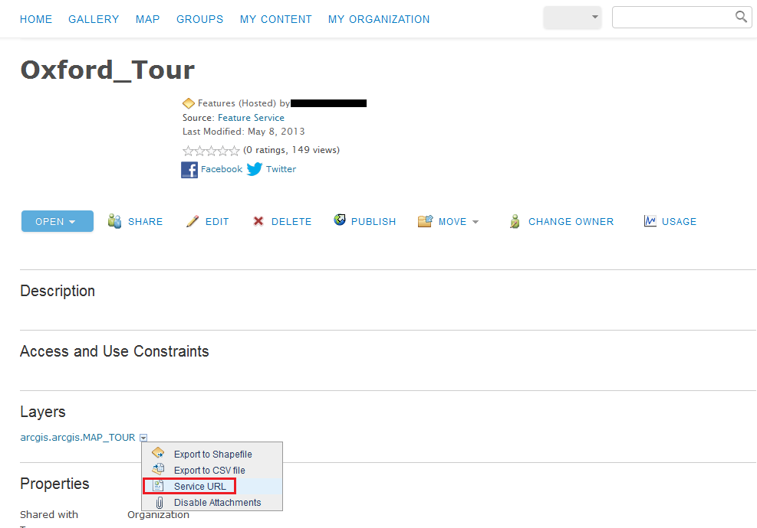

2. Click on the '*FeatureServer*' link at the top (under ArcGIS REST Services Directory).

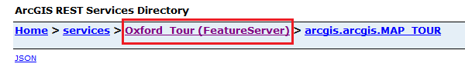

3. Select the '*Create Replica*' operation (bottom of the page).

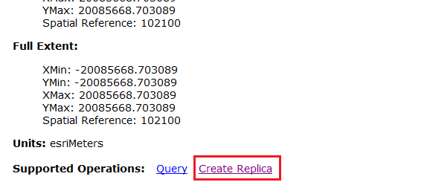4. Give the replica a name with no spaces.

5. Give '*Layers*' a value of **0** (zero)

6. Set  
    a) *Return Attachments* to '*True*'  
    b) *Sync Model* to '*none*'  
    c) *Data Format* to '*FILEGDB*'

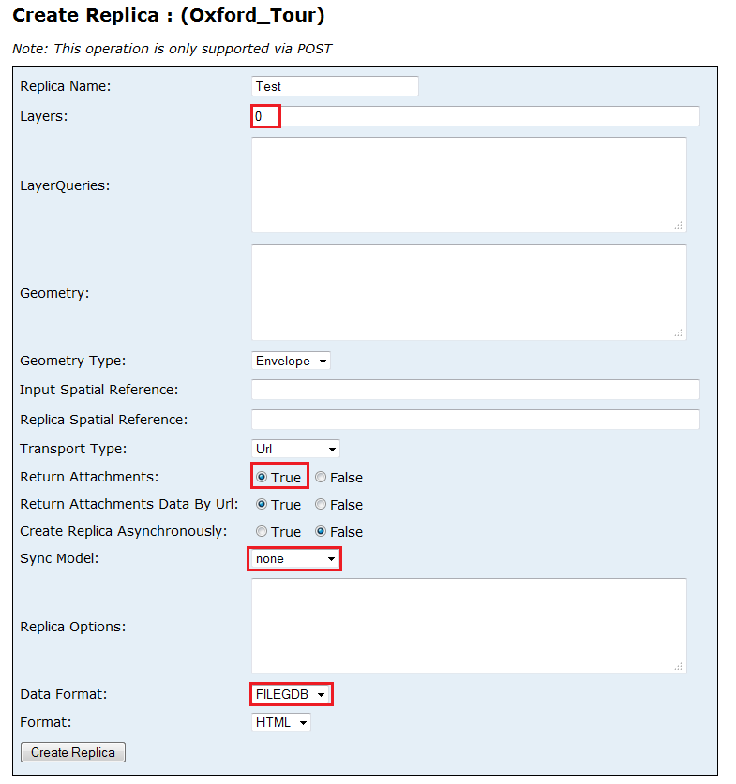7. Click '*Create Replica*'

8. Follow the Response URL to download the .zip file

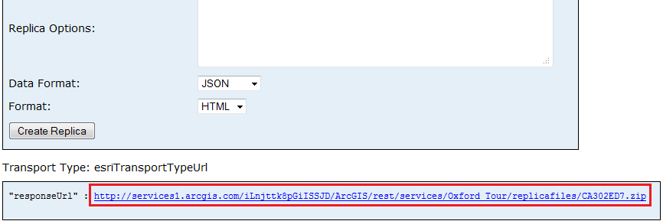

9. Use [7-Zip](http://www.7-zip.org/) to extract the content (The '*Extract...*' command built in to Windows won`t work!)

10. Add the .gdb extension to the folder name

For large datasets:

Follow steps 1-5 as shown above.  
6. Set  
    a) *Return Attachments* to '*True*'  
    b) *Create Replica Asynchronously* to '*True*'  
    c) *Sync Model* to '*none*'  
    d) *Data Format* to '*FILEGDB*'

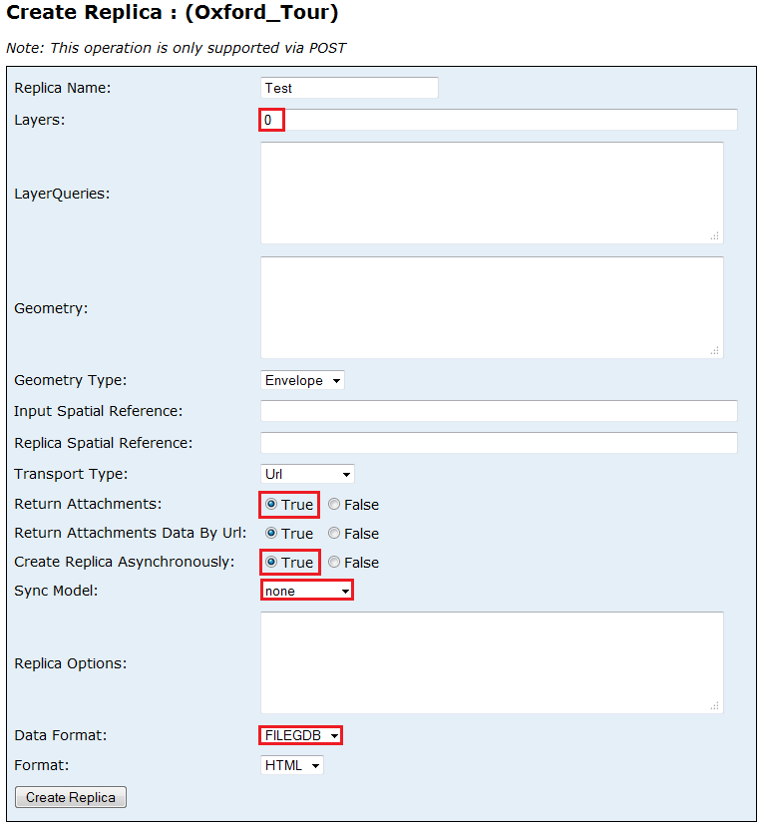

7. Click '*Create Replica*'

8. Follow the Response URL to download the .zip file

9. Use 7-Zip to extract the content

10. Add the .gdb extension to the folder name

**Extract attachments into a folder**

At the moment, there is no out-of the box tool in ArcGIS Desktop to extract attachments; however, you can perform this function through the use of a python script. You need to use the [arcpy.da](http://resources.arcgis.com/en/help/main/10.2/index.html" \l "/What_is_the_data_access_module/018w00000008000000/" \o "arcpy Data Access Module" \t "_blank) (data access) module to identify and iterate through the attachments table using a [Search Cursor](http://resources.arcgis.com/en/help/main/10.2/index.html#//018w00000011000000) and save the blob objects, that store the images, into physical files. (The arcpy.da module is only available in v10.1 and 10.2!)  
  
**Disclaimer: The below script is provided as-is and Esri UK accepts no responsibility of issues that arise from incorrect usage of this code.**

*from arcpy import da  
import os  
tbl = r"C:\TestProject\Attachments\test.gdb\yourFCname\_\_ATTACH"  
fldBLOB = 'DATA'  
fldAttName = 'ATT\_NAME'  
outFolder = r"C:\TestProject\Attachments\files"  
  
with da.SearchCursor(tbl,[fldBLOB,fldAttName]) as cursor:  
   for row in cursor:  
      binaryRep = row[0]  
      fileName = row[1]  
      # save to disk  
      open(outFolder + os.sep + fileName, 'wb').write(binaryRep.tobytes())  
      del row, binaryRep, filename*

Now you have a copy of your data and attachments to use locally, or for backup purposes.  
*Note:* You can extract the attachments using ArcObjects too, please see the API reference for more information.

* [10.0 ArcObjects .Net](http://help.arcgis.com/en/sdk/10.0/arcobjects_net/componenthelp/index.html#//004900000038000000)
* [10.1 & 10.2 ArcObjects .Net](http://resources.arcgis.com/en/help/arcobjects-net/componenthelp/index.html#//004900000038000000)